Macintosh Citrix Installation Instructions
Overview | This Guide is to help you install Citrix in order to use the Hanson Bridgett network from your personal Mac computer.  If you have any questions about these directions, please contact the Help Desk at x4444.
Before Starting | - Uninstall old versions of Citrix  In the Spotlight box, search for items with the word "Citrix" in the name. Remove all of these items, and then empty the trash.  - Restart your computer.
Installing Citrix | - Open a web browser, Navigate to www.citrix.com  - Click on Downloads  - Choose Citrix Receiver
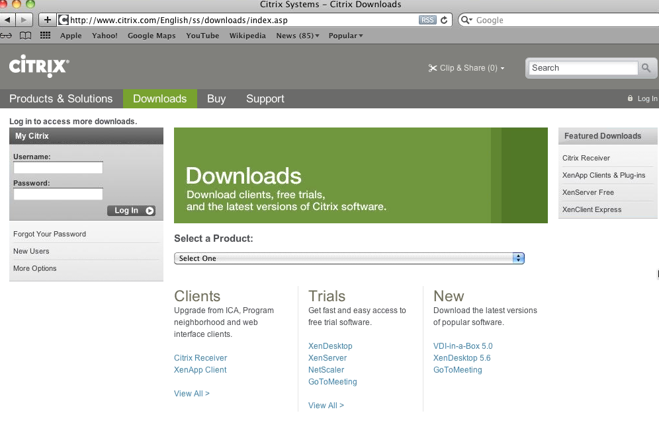
- Choose Mac OS X from the list
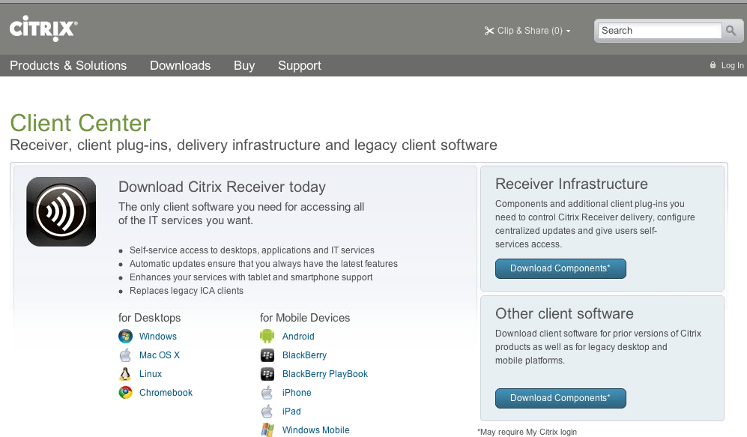
- Click Download
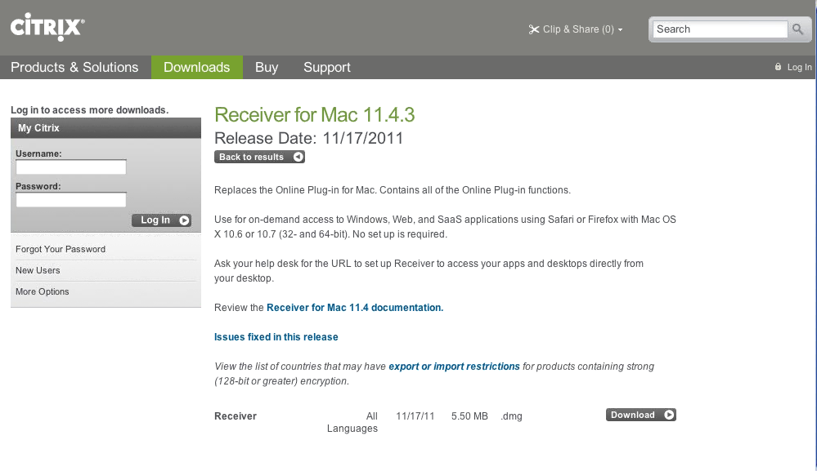
- Click Download Now in the Citrix Download Manager box
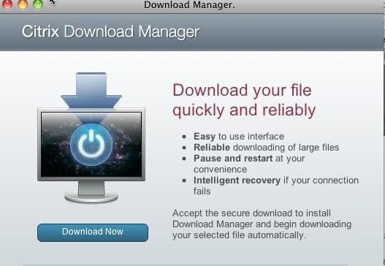
- From the Downloads box, double click on the CitrixReceiver.dmg
- Double click on the Install Citrix Receiver.pkg icon
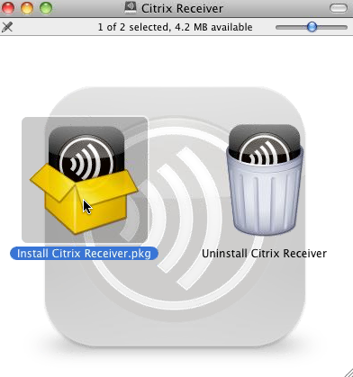
- Click Continue to Install Citrix Receiver
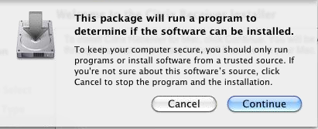
- Click Continue to Citrix Welcome
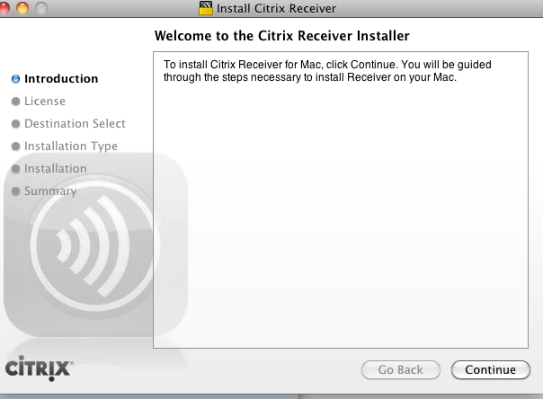
- Click Continue
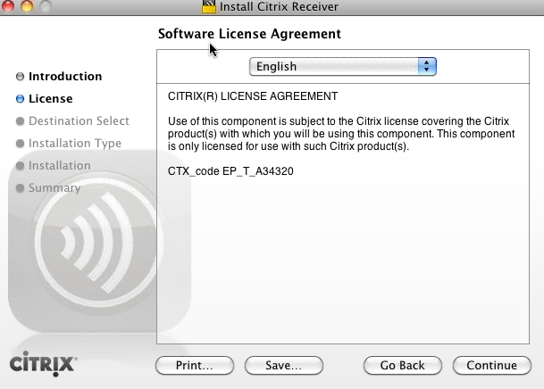
- Agree to the Citrix License Agreement
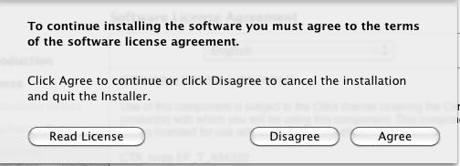
- Click Continue
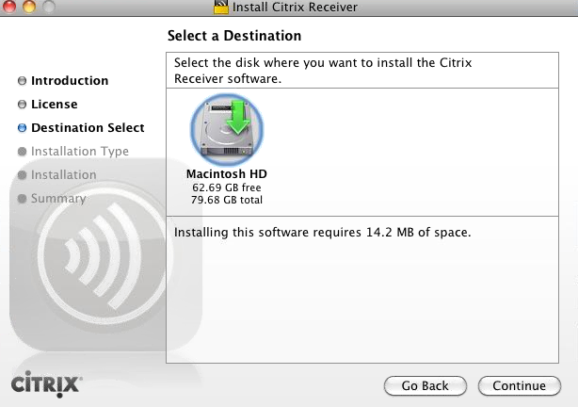
- Click Install
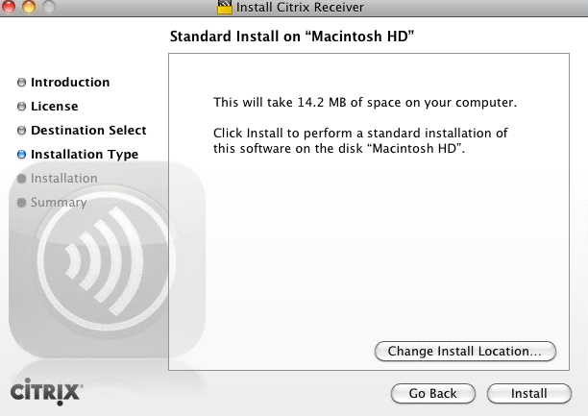
- Click Close to complete the installations

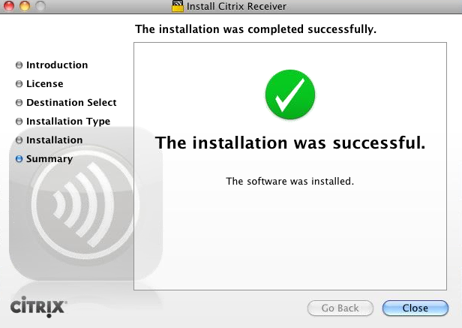

- Delete the Citrix Receiver .dmg file from your deskstop

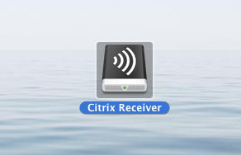

Configuring Citrix | - From the Spotlight, type Citrix in the box and press Enter  - Choose Citrix Receiver from the Applications result
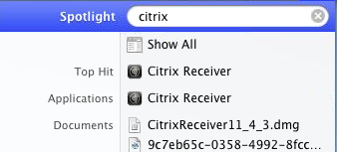

- From the Citrix Receiver Box, click Setup Now.
The Web Interface Applications page displays. At this point you can choose which applications to use. If you select Hanson Citrix Desktop with Filesite, you can get to all standard applications, including Outlook.
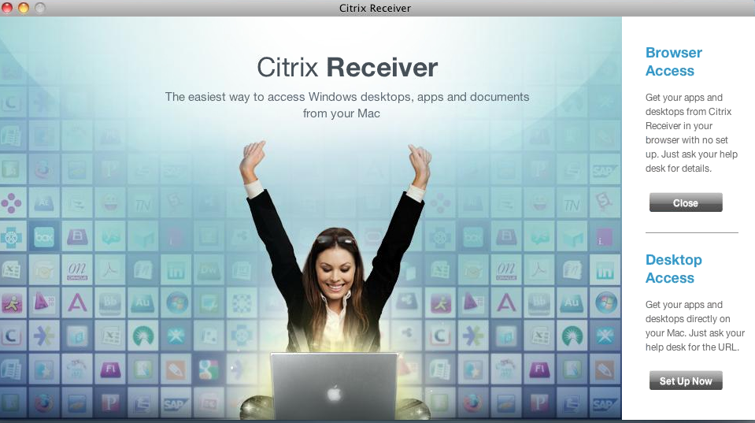

- In the Store URL, type https://ctxremote.hansonbridgett.com/citrix/pnagent1/config.xml
- Click OK

- Click OK

- Type in your Hanson Bridgett Username and password as follows:
hanson\[user initials]
[your network password]
- Click Connect
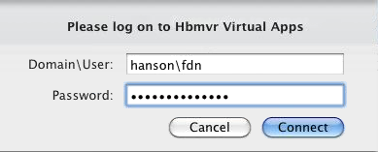

- Click Add next to the Hanson Bridgett Applications you want to access
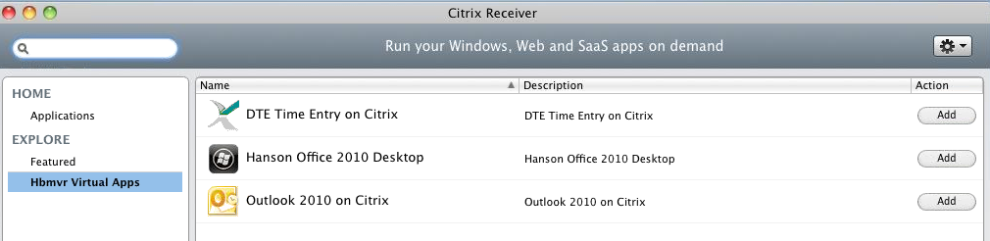

- Click on Applications and you will see the list.
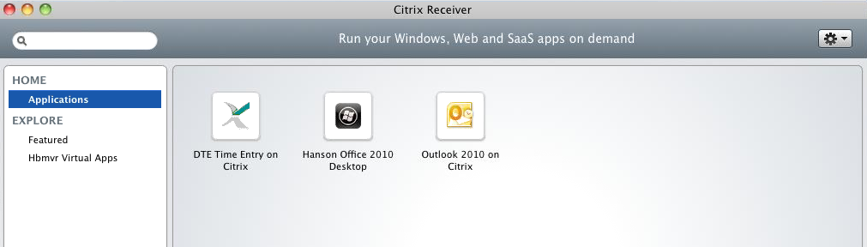

- Right Click on the Citrix Receiver icon in your Dock
- Choose Options
- Click Keep in Dock
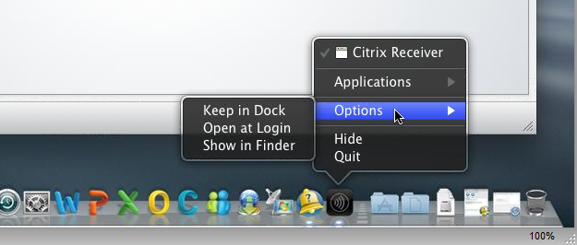

Accessing Citrix | - From the Dock, launch the Citrix Receiver
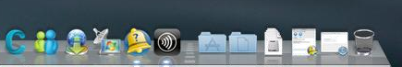

- Double Click on the icon you want to launch.
- Login.

Getting Help | Call the Help Desk at ext. 4444. If you are outside of the office, dial 415-995-5844. You can also email the Help Desk by addressing your email to help. Please put a short description of your issue or request in the text portion of the message. Contacting the Help Desk ensures that your request is added properly to our ticketing system and that issues are assigned to the appropriate IT team member.  After-Hours Support - For after-hours and weekend assistance call the Help Desk at 415-995-5844.  Emergency Support - Call the support pager by dialing (877) 216-8607. At the prompt, enter your call back number, including area code, and hang up.

